-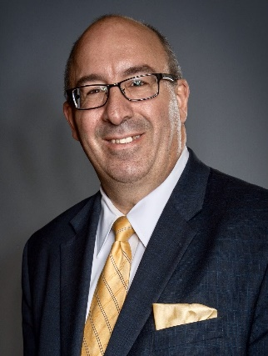
BIO
Michael Soos is a distinguished professional. With an illustrious career spanning over 34 years in the financial services industry, he has made significant contributions while working with a leading Fortune 500 company. Throughout his tenure, Michael has demonstrated unwavering dedication to assisting financial professionals and their clients in crafting comprehensive retirement plans. Possessing a wealth of experience in Social Security and Medicare, Michael is recognized as a specialist. His profound knowledge and insights make him an invaluable resource for financial advisors, CPA’s and attorneys seeking solutions for their clients’ income planning needs. By sharing time-tested business strategies and offering education on industry-related changes, he empowers these professionals to enhance their practices and serve their clients more effectively. As a testament to his commitment to knowledge dissemination, Michael has conducted over 2000 workshops and lectures on Social Security and Medicare. Additionally, he has been a Continuing Education Instructor for more than 26 years. He graduated from St. John’s University where he earned a bachelor’s degree in business management.
Residing in Mooresville, North Carolina, Michael cherishes his time with his wife, and their three adopted children. Outside of his professional endeavors, he enjoys competitive powerlifting, travelling with his family, fishing, and indulging in the game of golf.
He is the author of “Don’t Leave Money on the Table” Maximizing Social Security and Medicare Benefits, A guide for Financial Advisors.

Navigating Social Security isn't as straight forward as you might think. Maximizing, or at least preserving your benefit amount takes forethought, planning, and oftentimes collaboration. It's not just a matter of claiming your benefits and collecting a check. There's actually a lot of strategy that goes into effectively managing Social Security income. Understanding how to implement successful claiming strategies can help your clients avoid leaving money on the table and keep more of what they deserve.
Additionally, managing Medicare costs can be complex and confusing at times. Learning the important ins and outs of Social Security and managing healthcare costs are a few elements of preparing for a confident retirement. Speak with me today and see how I can help!

Registered representative of, and securities offered through Hornor, Townsend & Kent, LLC (HTK), Member FINRA/SIPC, 600 Dresher Road, Horsham, PA 19044. 800-873-7637, www.htk.com. HTK is a wholly-owned subsidiary of the Penn Mutual Life Insurance Company. Strategic Planning Group is unaffiliated with HTK. HTK does not offer tax or legal advice. Always consult a qualified adviser regarding your individual circumstances.
6739543RG_Sep24

