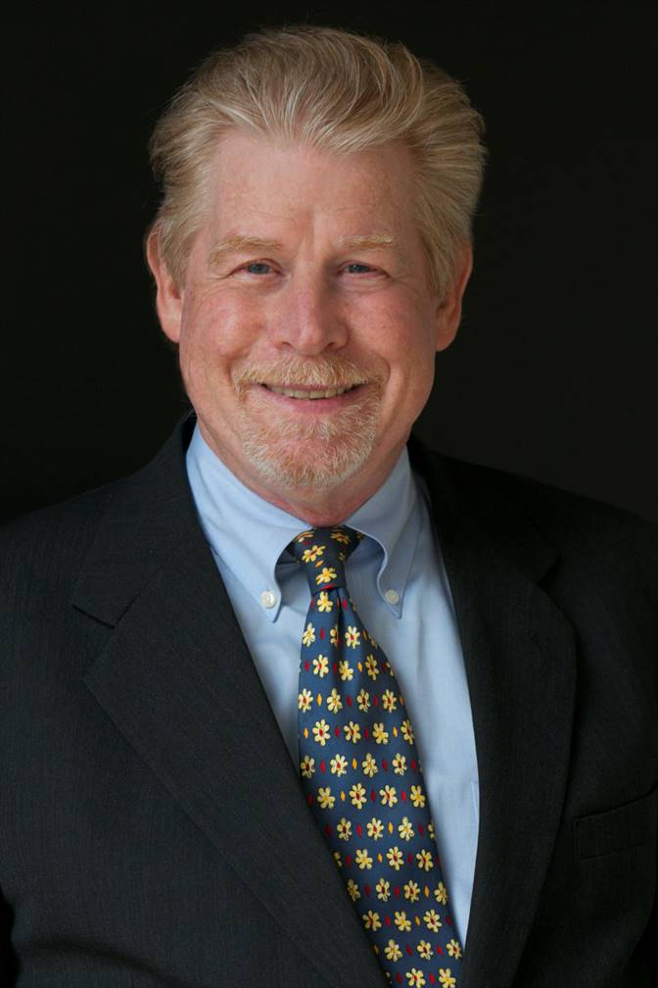

Joseph (Jay) B. Darby III

Joseph (“Jay”) B. Darby III is the founder of Joseph Darby Law PC and has more than thirty years of experience representing clients in a wide range of tax, estate planning, and related business matters. His goal is to help clients enjoy their lives by reducing taxes, avoiding (or resolving) problems with taxing authorities, and passing personal wealth to the appropriate next destination.

Jay's clients range from individuals to large public and private business entities, and while he has structured some of the most sophisticated transactions in the business arena, he is mindful of the fact that people rather than businesses ultimately pay taxes. Therefore, he always structures transactions with the goal of minimizing the tax costs and maximizing the after-tax return for the people he represents.

An early proponent of Opportunity Zones (an investment incentive created under the 2017 Tax Act), Jay has become one of the country’s go-to experts in the area, helping clients bring business investment and ultimately prosperity to some of the most challenged areas of the country.
​
Jay is the author of a highly acclaimed treatise, Practical Guide to Mergers, Acquisitions and Business Sales. He has written more than 1,000 articles on tax, business, and a diverse range of other topics. He teaches numerous advanced tax courses at Boston University School of Law's Graduate Tax Program, and has taught regularly at Boston College Law School and Bentley College (in the Masters of Taxation program). He is a popular speaker on the national tax conference and webinar circuit, lecturing regularly on a wide range of topics. He is also the founder and principal host of the OZoom Forum, a video-conferencing platform sponsored by Boston University School of Law that provides a venue for sharing information and ideas about Opportunity Zones and related subjects.

Jay’s many awards and honors include being recognized in the area of tax practice by Best Lawyers in America® from 2010 through 2022, being recognized for his achievements in Legal 500 U.S., being named a “Top 25 Opportunity Zone Influencer” by Opportunity Zone Expo Magazine for 2019 through 2022, and receiving an AV Preeminent®, Martindale-Hubbell® Peer Review Rating™.

Jay was a tax partner at some of the largest and most prestigious law firms in the country, including Greenberg Traurig LLP and Holland & Knight LLP, before founding his own firm, Joseph Darby Law PC.

