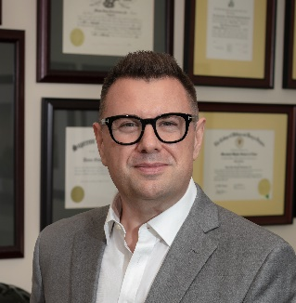

**Dana G. Fitzsimons Jr., Managing Director and   
Senior Fiduciary Counsel**

Mr. Fitzsimons is Managing Director and Senior Fiduciary Counsel at Bessemer Trust. In this role, he is responsible for workingwith clients and their advisors to develop practical and efficient wealth transfer plans, and for guiding the firm on fiduciary issues. He serves as Chair of the firm’s Fiduciary Counsel Committee and its Diminished Capacity Working Group.

Prior to joining Bessemer, Dana was a partner with McGuireWoods LLP, where he practiced in the areas of fiduciary litigation and estate planning.

He is a Fellow of the American College of Trust & Estate Counsel (ACTEC) and serves as Chair of its Long-Range Planning Committee, on its Board of Regents and on its State Laws Subcommittee. Dana serves in the ABA RPTE Section leadership on its Planning Committee. He has been recognized in *Chambers USA: America’s Leading Lawyers for Business*, is a 2021 inductee into the NAEPC Association Estate Planning Hall of Fame, and frequently lectures on fiduciary topics.

Dana earned a J.D. from William & Mary Law School, where he was a member of the law review and graduated *Order of the Coif,* and a B.A. in music from Ithaca College School of Music. He continues to actively perform and record as a jazz and rock drummer.