Greenville Estate Planning Council

Spring Social

The Venue at Falls Park
631 South Main Street
Greenville, South Carolina 29601

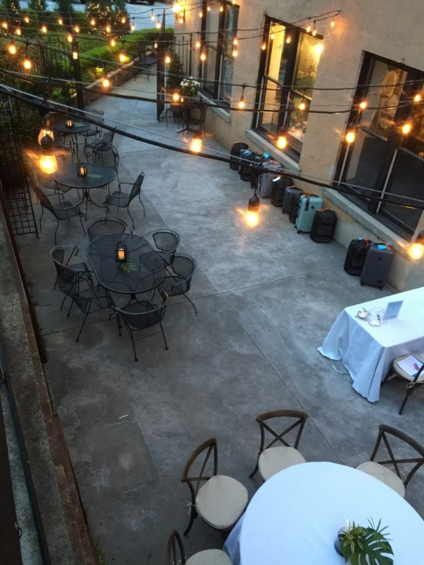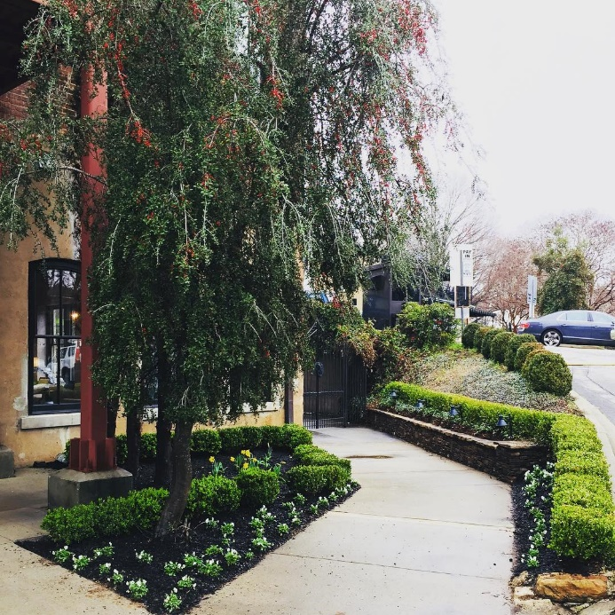

Join us for food, drinks, and fun!
Date: Tuesday, May 10, 2022
Time: 5:30pm - 7:30pm
Location: The Venue at Falls Park
No Charge for Members, Spouses/Guests are welcome! ($20 each)
Questions? Contact: gepcgreenville@gmail.com

